**Chapter 4.5: Getting Help in Red Hat Enterprise Linux**

Marko Shaffer

Information Technology, Franklin University

ITEC 200: Linux Fundamentals

Professor Kagan Ulucay

6/4/2023

Red Hat System Administration I 8.2

Chapter 4.5 - Lab: Getting Help in Red Hat Enterprise Linux

**Performance Checklist:**

In this lab, you will look up information to help you complete tasks in man pages and GNU Info documents.

**Outcomes:**

You should be able to:

* Locate relevant commands by searching man pages and Info nodes.
* Learn new options for commonly used documentation commands.
* Use appropriate tools to view and print documentation and other non-text formatted files.

Log in to workstation as student using student as the password.

|  |  |  |  |
| --- | --- | --- | --- |
|  | Franklin VM: | Standard User Account: | The Student's Root Account: |
| Username | kiosk | student | root |
| Password | redhat | student | redhat |

On the workstation, run the **lab cli-review start** script to set up a clean lab environment. The script also copies the zcat file to the student's home directory.

**[student@workstation ~]$ lab cli-review start**

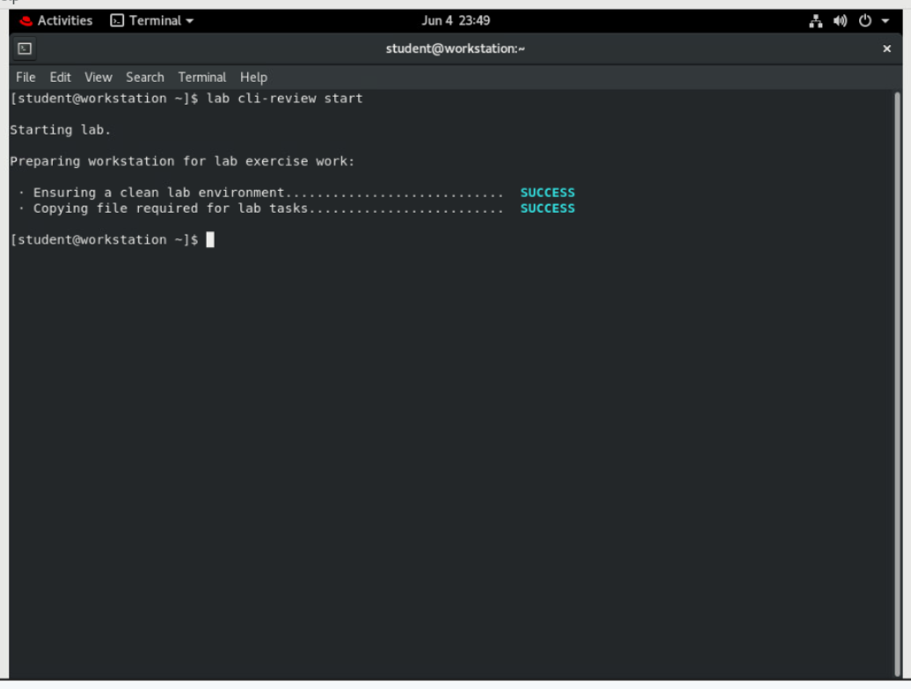

**[student@workstation ~]$ lab help-review start**

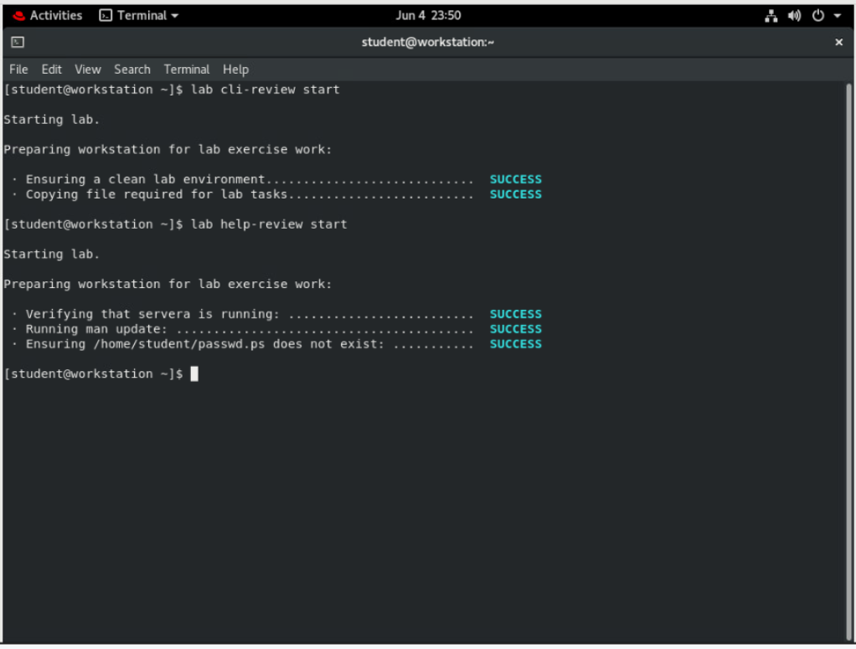

1. **On workstation, determine how to prepare a man page for printing. Specifically, find what format or rendering language is used for printing.**

Use the **man man** command to determine how to prepare a man page for printing.

**[student@worksation ~]$ man man**

*...output omitted...*

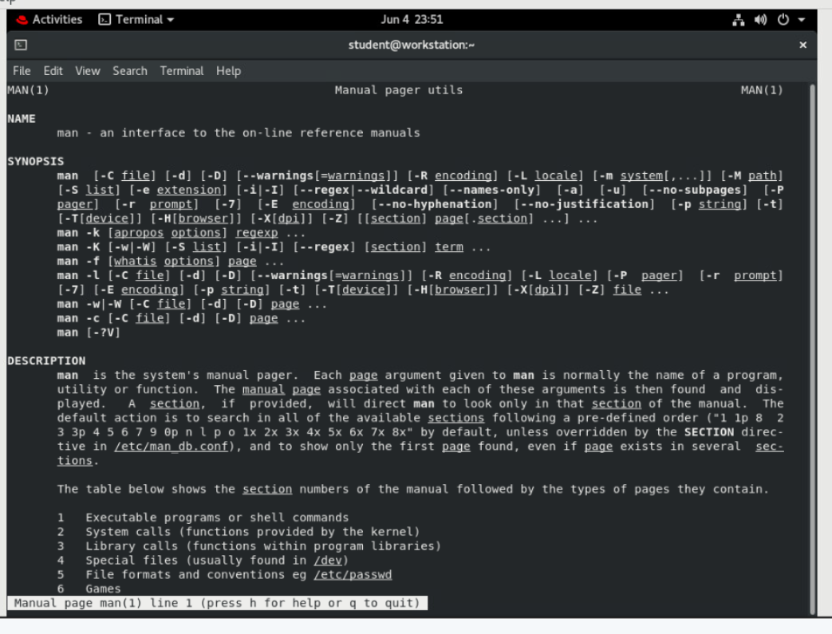

Press **q** to quit the man page.

Note: **man** uses **-t** to prepare a man page for printing, using PostScript.

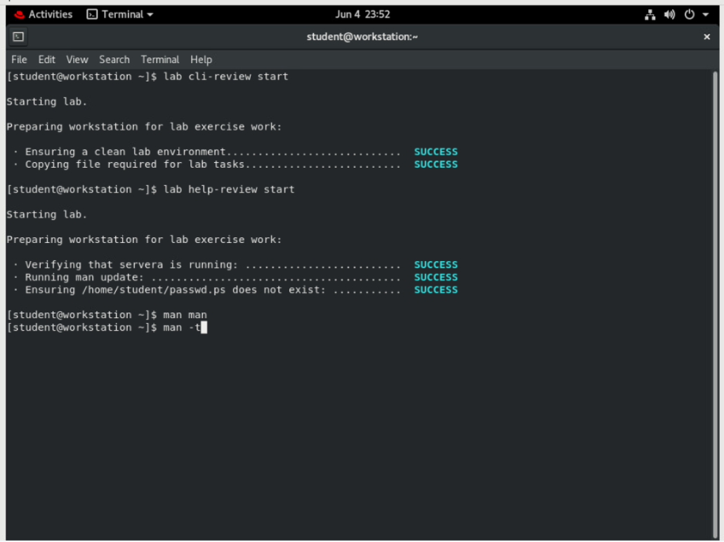

1. **Create a formatted output file of the passwd man page. Call the file passwd.ps. Determine the file content format. Inspect the contents of the passwd.ps file.**

Note: Create formatted output of the **passwd** man page using the following command:

**[student@workstation $]$ man -t passwd > passwd.ps**

The **>** symbol *redirects* the contents of the man page to the passwd.ps file. This command is taught in more detail in a following chapter.

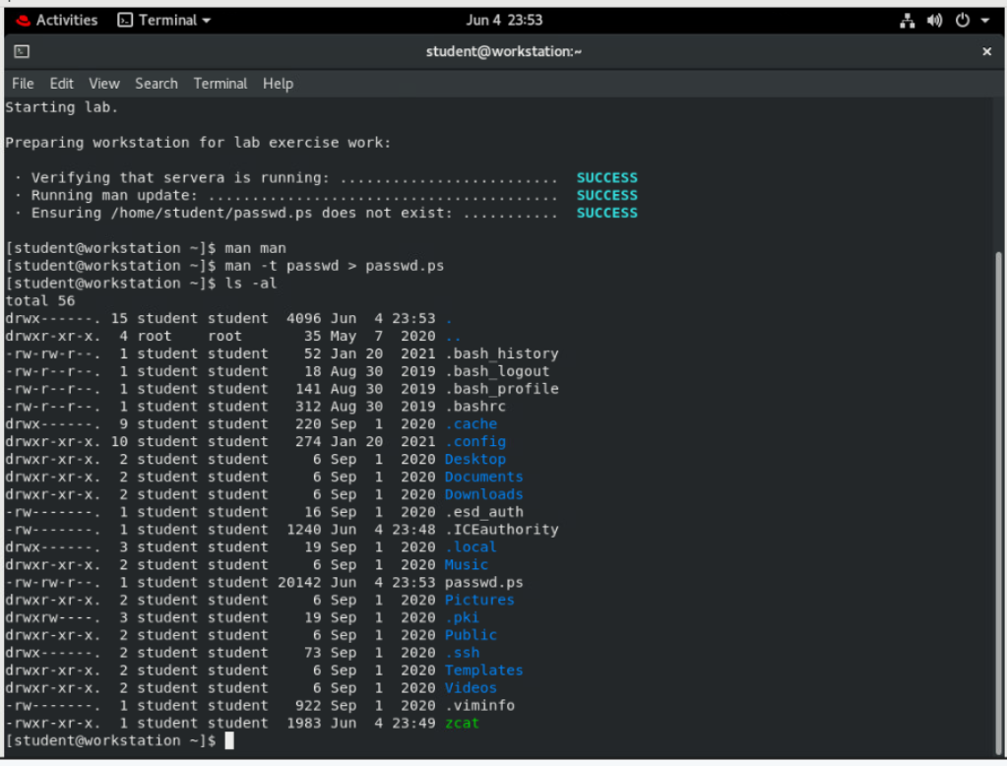

**Use the man -t command to create a formatted file of the passwd man page.**

**[student@workstation ~]$ man -t passwd > passwd.ps**

**[student@workstation ~]$ ls -al**

*...output omitted...*

-rw-rw-r--. 1 student student 19947 Feb 26 11:14 passwd.ps

*...output omitted...*

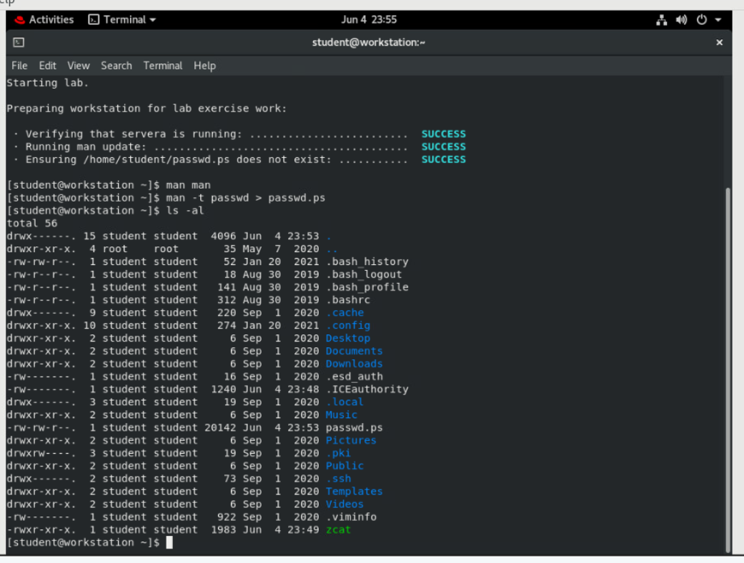

**Use the file command to determine the file content format.**

**[student@workstation ~]$ file /home/student/passwd.ps**

passwd.ps: **PostScript** document text conforming DSC level 3.0

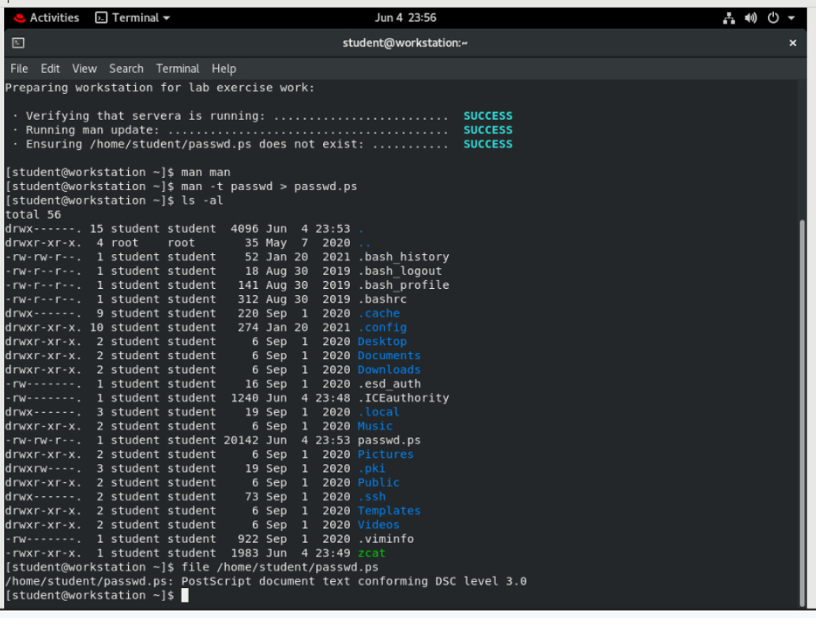

**Use the less command to view the /home/student/passwd.ps file.**

**[student@workstation ~]$ less /home/student/passwd.ps**

%!PS-Adobe-3.0

%%Creator: groff version 1.22.3

%%CreationDate: Tue Feb 26 11:14:40 2019

%%DocumentNeededResources: font Times-Roman

%%+ font Times-Bold

%%+ font Times-Italic

%%+ font Symbol

%%DocumentSuppliedResources: procset grops 1.22 3

*...output omitted...*

Note: The output of **file** asserts that the file is in the PostScript format, and you have confirmed it by viewing its contents. Notice the header lines of PostScript information. Use **q** to quit the **less** command.

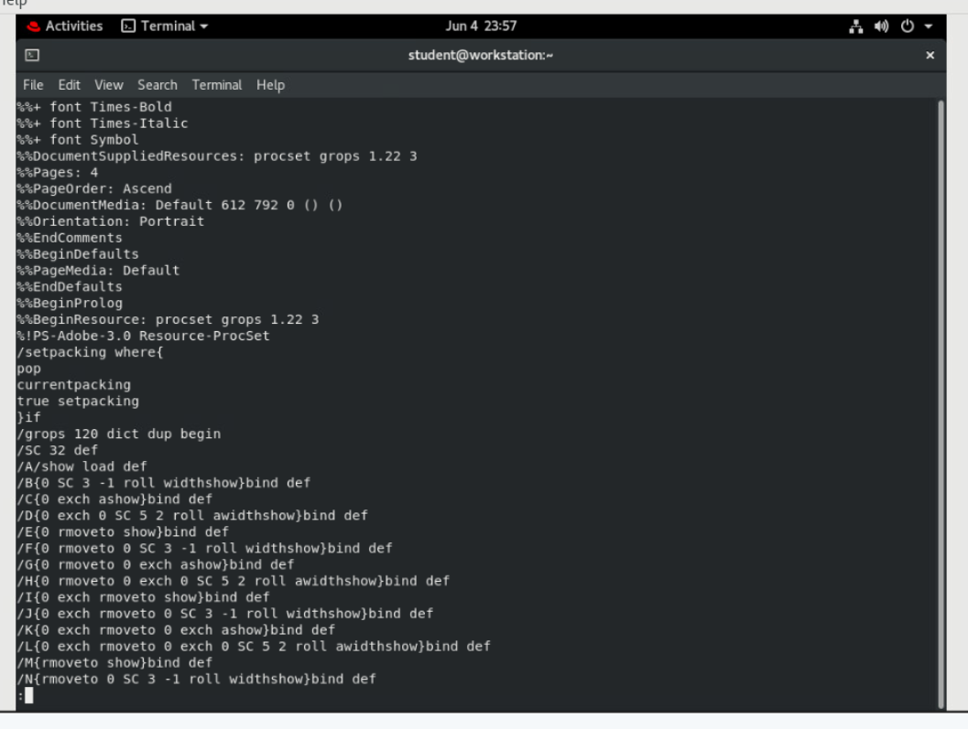

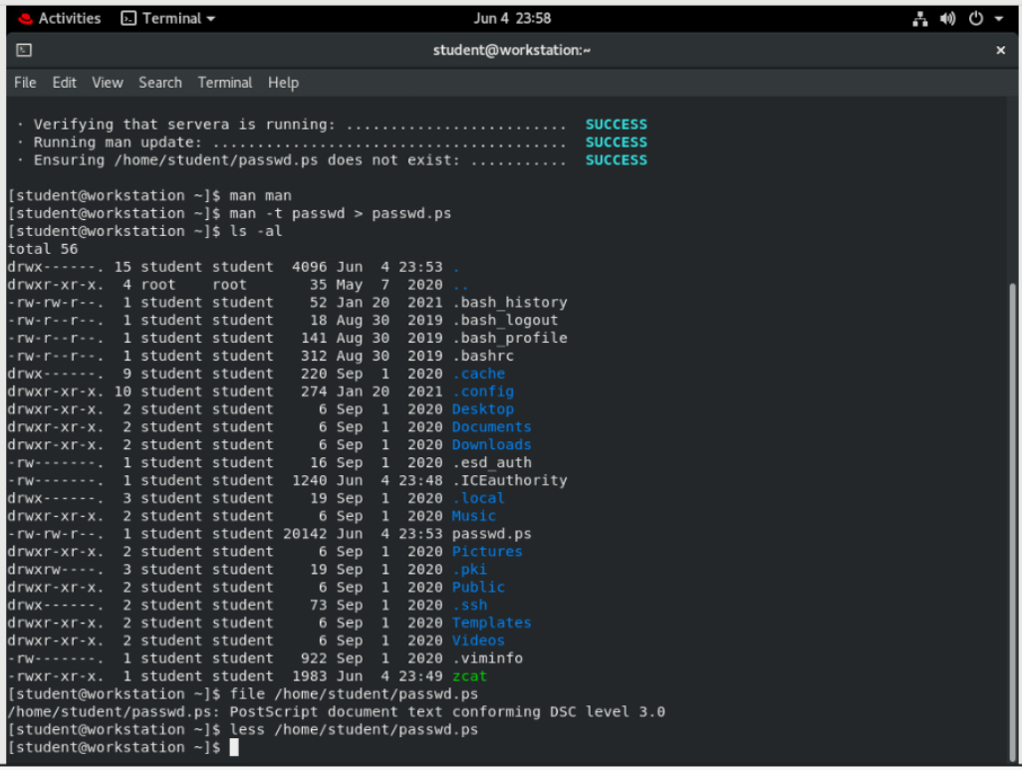man

1. **Using man, learn the commands used for viewing and printing PostScript files.**

Using **man** learn the commands used for viewing and printing PostScript files.

**[student@workstation ~]# man -k postscript viewer**

**evince (1)** - GNOME document viewer

evince-previewer (1) - show a printing preview of PostScript and PDF documents

evince-thumbnailer (1) - create png thumbnails from PostScript and PDF documents

gcm-viewer (1) - GNOME Color Manager Profile Viewer Tool

gnome-logs (1) - log viewer for the systemd journal

grops (1) - PostScript driver for groff

pango-view (1) - Pango text viewer

pluginviewer (8) - list loadable SASL plugins and their properties

Note: Using multiple words with the **-k** option finds man pages matching *either* word; those with "postscript" *or* "viewer" in their descriptions. Notice the **evince**(1) commands in the output.

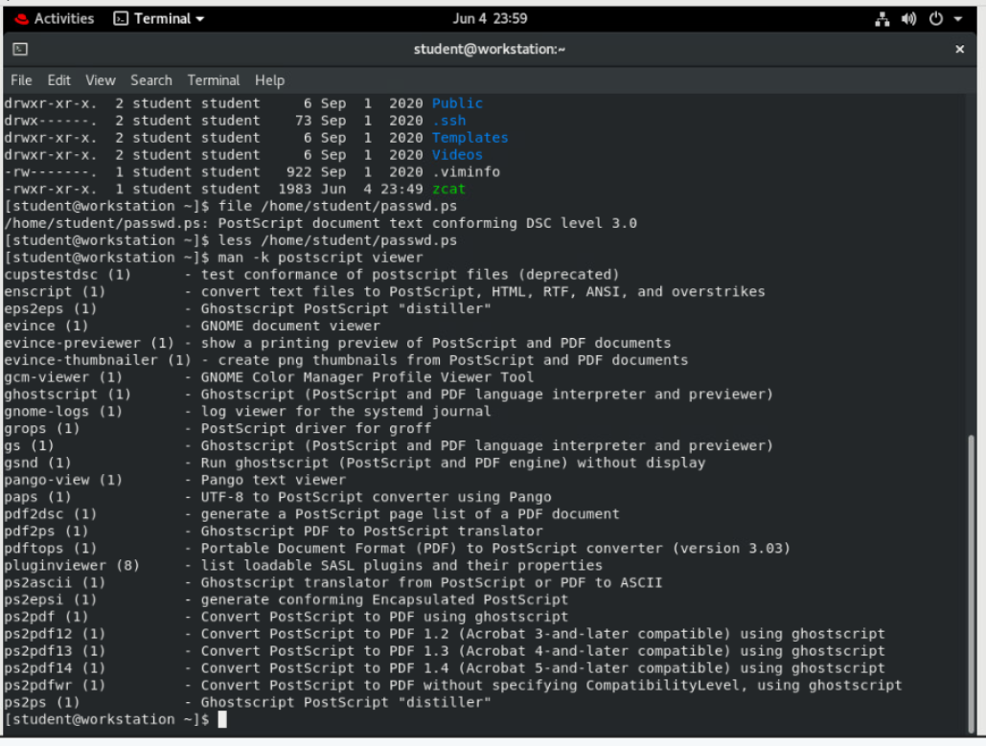

1. **Learn how to use the evince(1) viewer in preview mode. Also, determine how to open a document starting on a specific page.**

Use the **man evince** command to learn how to use the viewer in preview mode.

**[student@workstation ~]$ man evince**

*...output omitted...*

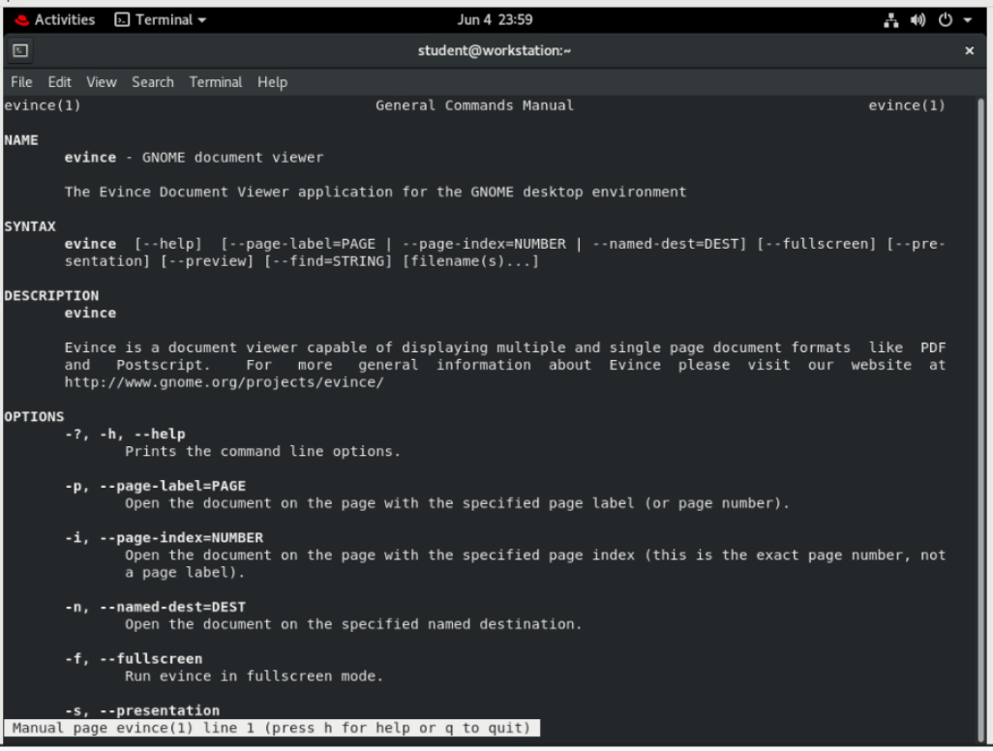

Press **q** to quit the man page.

Note: The -w (or --preview) option opens evince in preview mode. The -i option is used to specify a starting page.

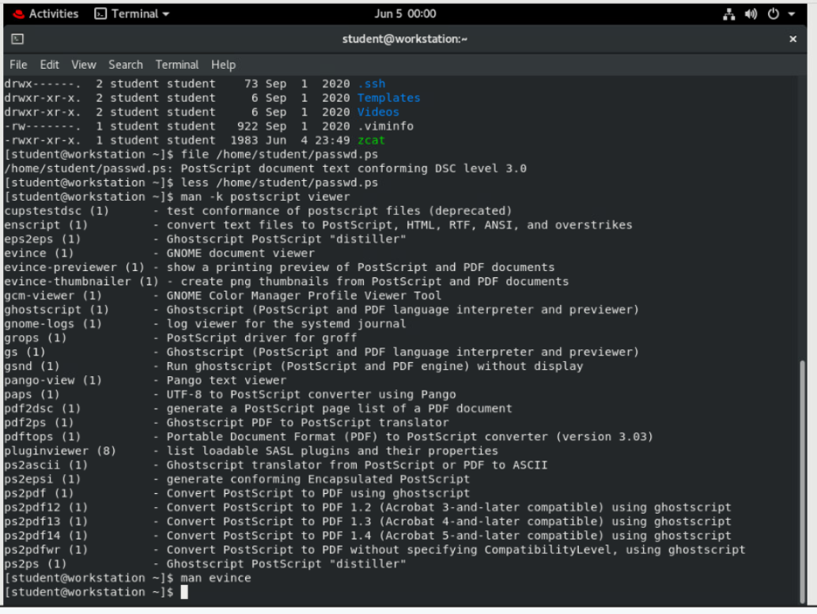

1. **View your PostScript file using the various evince options you researched. Close your document file when you are finished.**

Use the **evince** command to open /home/student/passwd.ps

**[student@workstation ~]$ evince /home/student/passwd.ps**

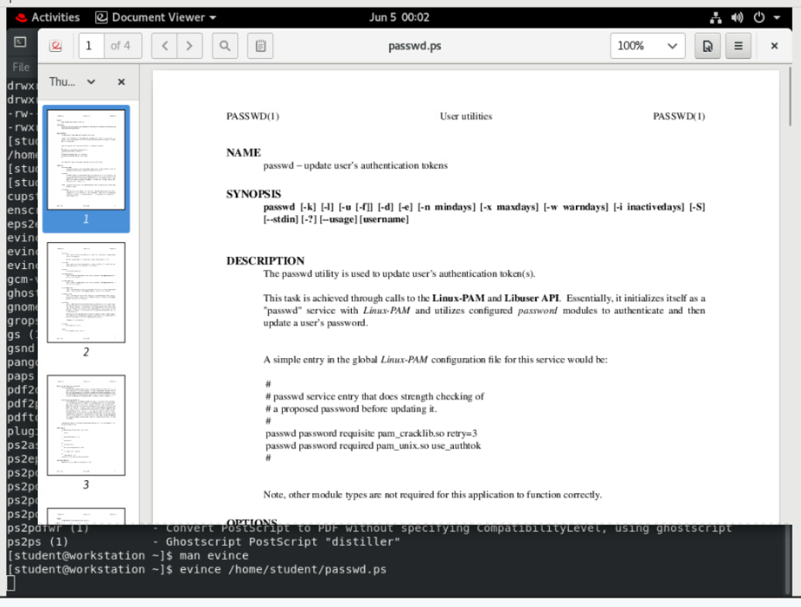

Use the **evince -w /home/student/passwd.ps** command to open the file in preview mode.

**[student@workstation ~]$ evince -w /home/student/passwd.ps**

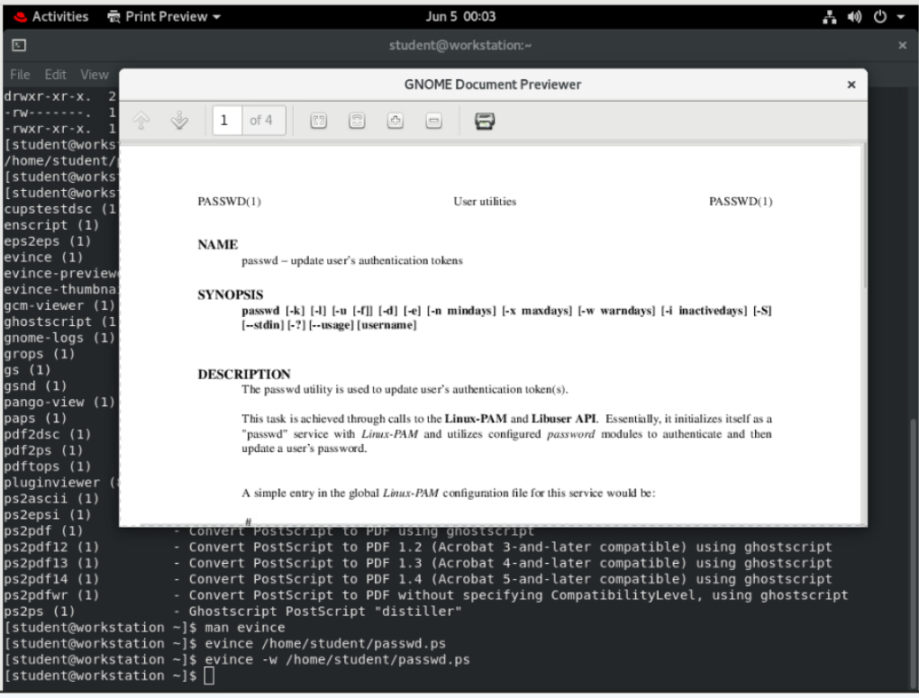

Use the **evince -i 3 /home/student/passwd.ps** command to open the file at page 3.

**[student@workstation ~]$ evince -i 3 /home/student/passwd.ps**

Note: While normal **evince** mode allows full screen and presentation style viewing, the **evince** preview mode is useful for quick browsing and printing. Notice the **print icon** at the top.

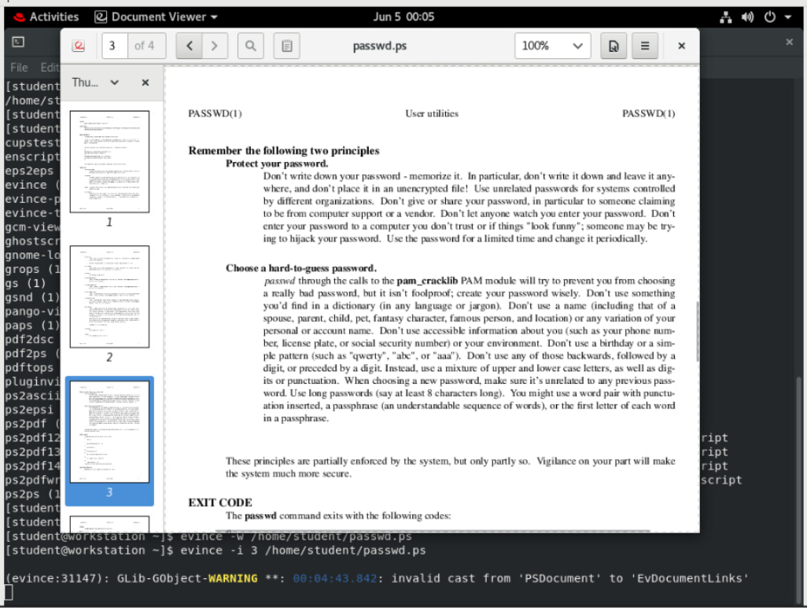

1. **Using the man command, research lp(1) to determine how to print any document starting on a specific page. Without actually entering any commands (because there are no printers), learn the syntax, in one command, to print only pages 2 and 3 of your PostScript file.**

Use the **man lp** command to determine how to print specific pages of a document.

**[student@workstation ~]$ man lp**

*...output omitted...*

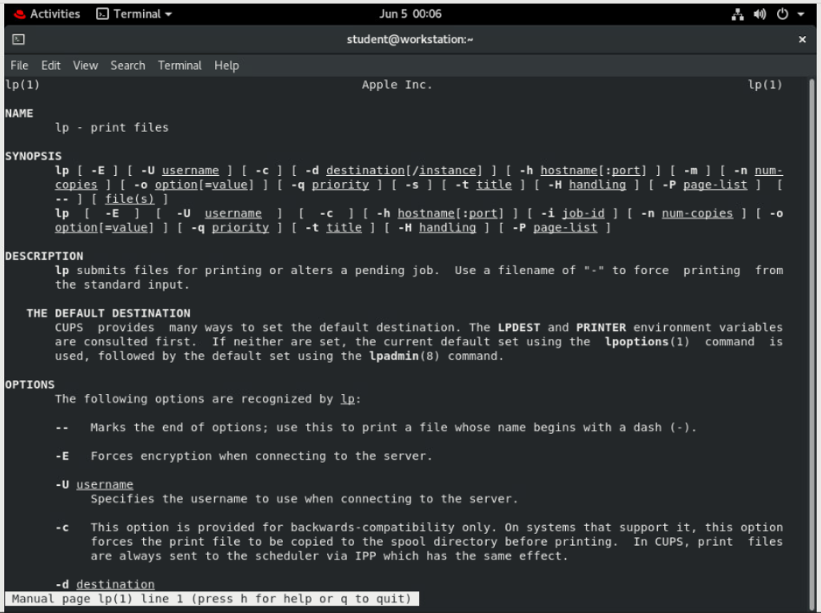

Press **q** to quit the man page.

Note: From lp(1), you learn that the -P option specifies pages. The lp command spools to the *default* printer, sending only the page range starting on 2 and ending on 3. Therefore, one valid answer is **lp passwd.ps -P 2-3**.

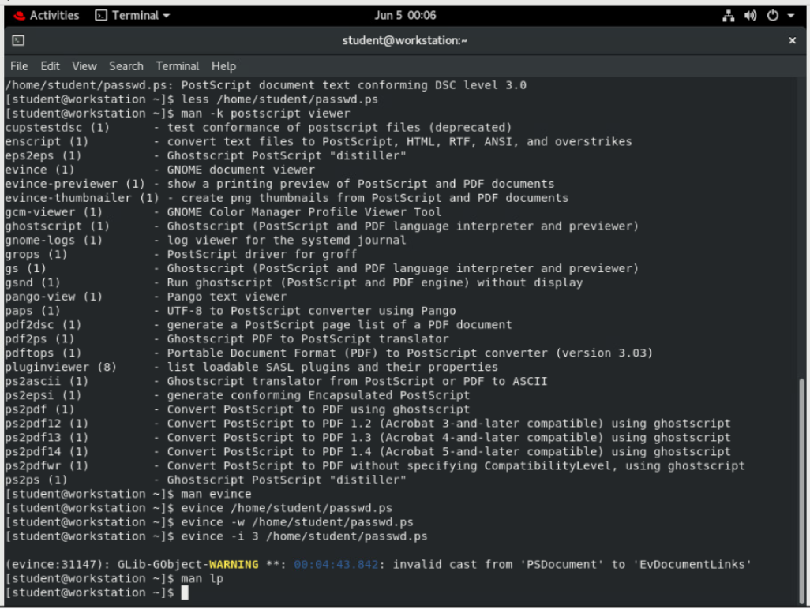

1. **Using pinfo, look for GNU Info documentation about the evince viewer**.

Use the **pinfo command** to look for GNU Info documentation about the **evince** viewer.

**[student@workstation ~]$ pinfo evince**

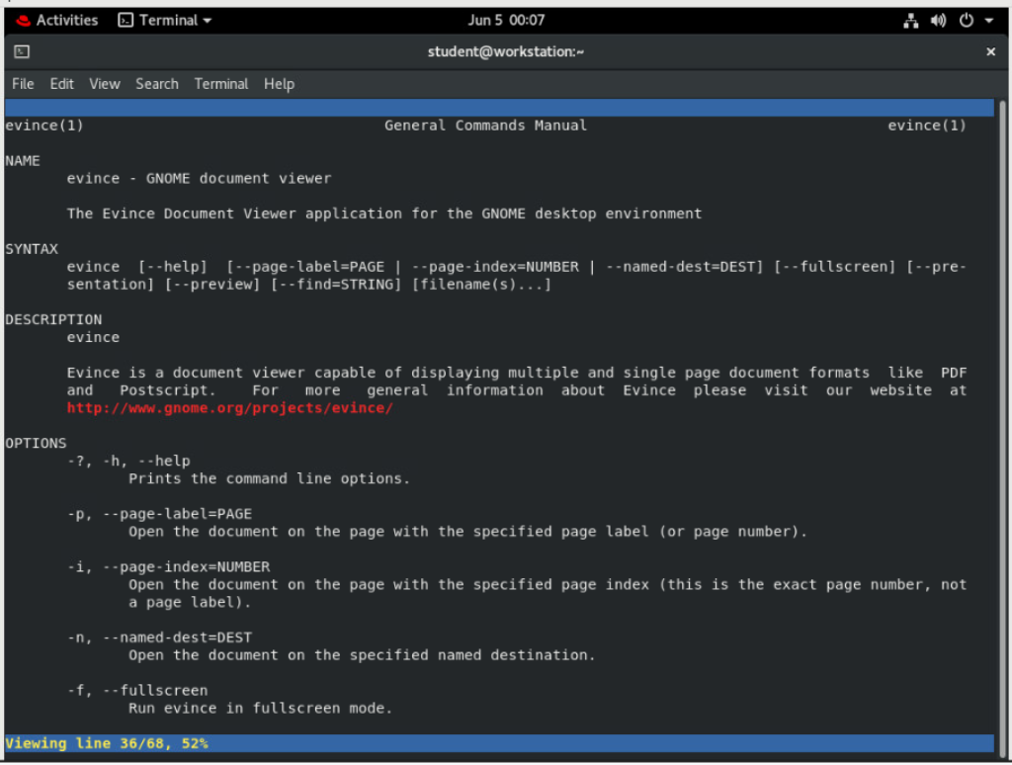

Note: Notice that the evince(1) man page displays instead. The **pinfo** document viewer looks for a relevant man page when no appropriate GNU documentation node exists for the requested topic. Press **q** to quit.

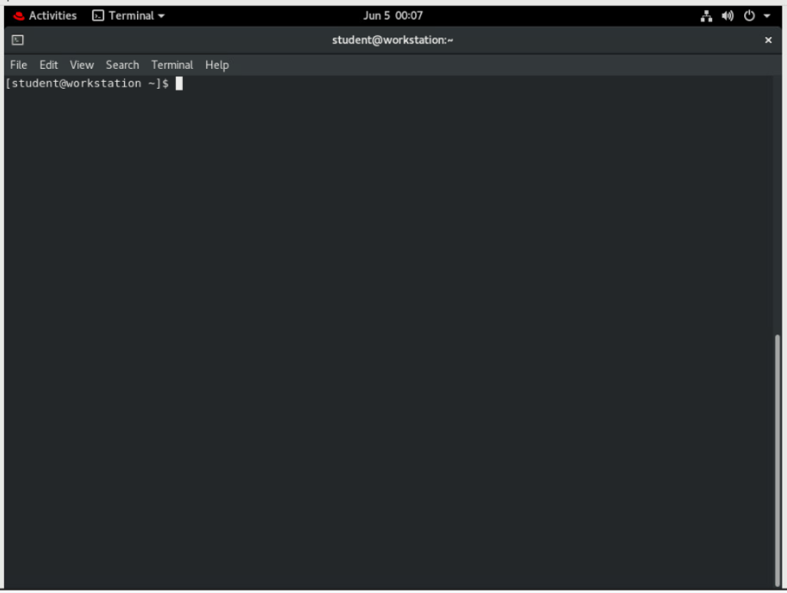

1. **Using Firefox, open the system's package documentation directory and browse into the man-db package subdirectory. View the provided manuals.**

Use **firefox /usr/share/doc** to view system documentation. Browse to the man-db subdirectory. Click on the manuals to view them.

**[student@workstation ~]$ firefox /usr/share/doc**

Note: Bookmarks can be made for any frequently used directory. After browsing to the man-db directory, click to open and view the text version of the manual, then close it. Click to open the PostScript version. As observed earlier, **evince** is the system's default viewer for PostScript and PDF documents. You may wish to return to these documents later to become more knowledgeable about **man**. When finished, close the **evince** viewer.

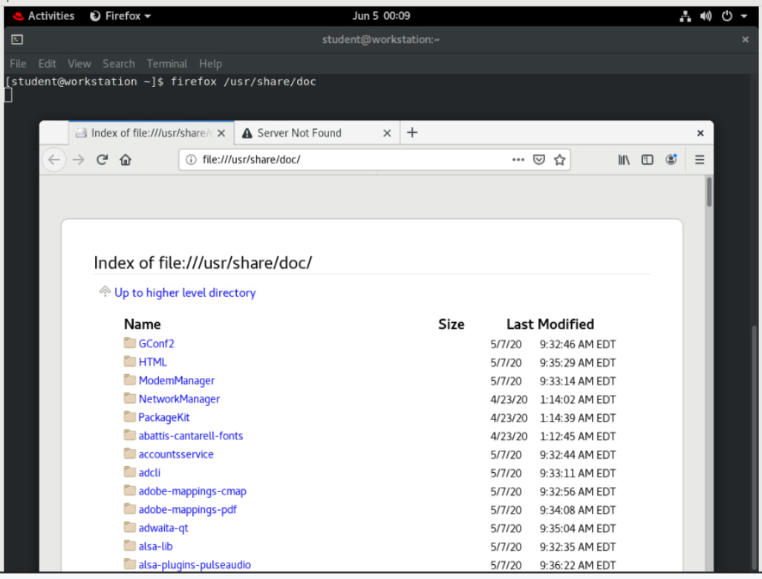

|  |
| --- |
|  |

1. Using the Firefox browser, locate and browse to the initscripts package subdirectory. View the sysconfig.txt file, which describes important system configuration options stored in the /etc/sysconfig directory.

In the Firefox browser, locate the initscripts package subdirectory.

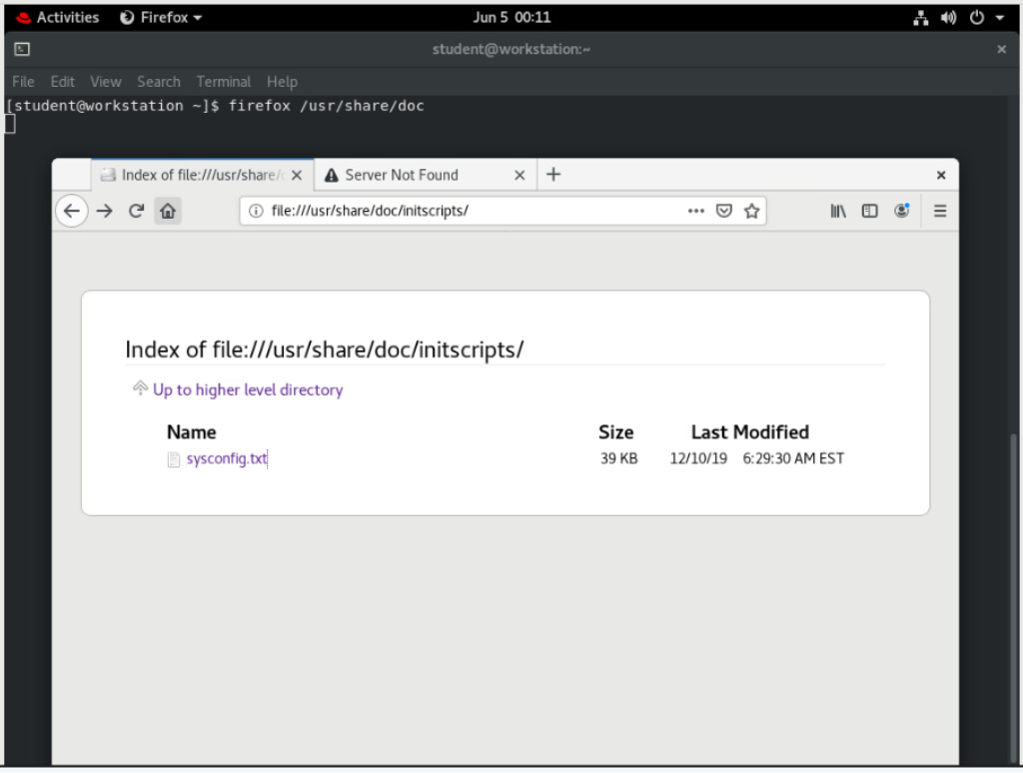

Notice how useful a browser is for locating and viewing local system documentation. Close the document and Firefox when finished.

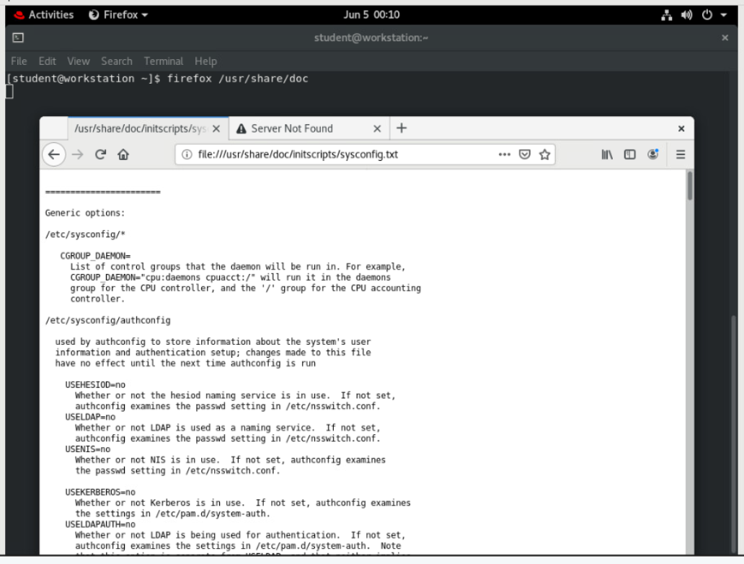

**Evaluation**

On workstation, run **lab help-review grade** to confirm success of this exercise.

**[student@workstation ~]$ lab help-review grade**

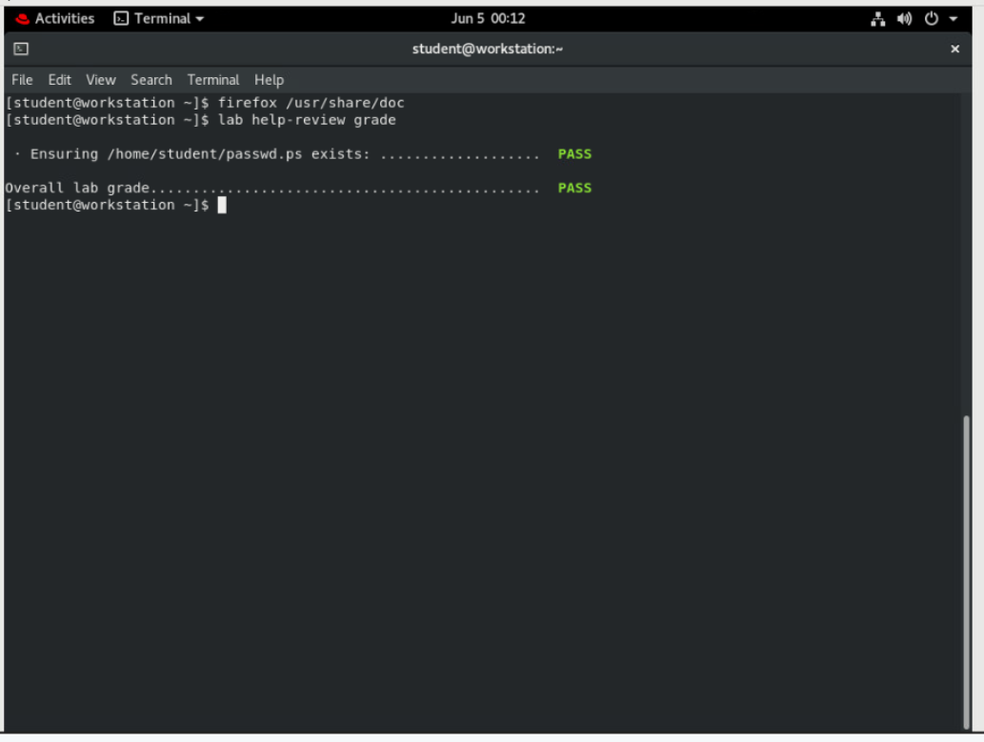

**Finish**

On workstation, run the **lab help-review finish** script to complete this exercise.

**[student@workstation ~]$ lab help-review finish**

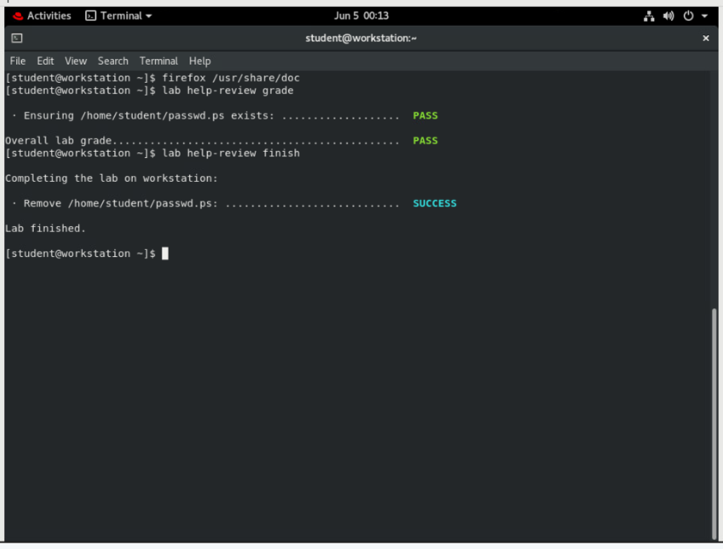

This concludes the lab.